Importing data

There are a total of 3 tables which are converted to 1 table name school and saved as a csv file.
For performing EDA in python we have to use code:

import pandas as pd
file_path = r'C:\Users\al6436\Downloads\school.csv'
df = pd.read_csv(file_path)

Inspecting the data

print("Data Overview:")
print(df.head())
print("\nData Types and Missing Values:")
print(df.info())
print("\nSummary Statistics:")
print(df.describe())
print("\nMissing Values:")
print(df.isnull().sum())

Overview of the data as for each columns

print("Student_ID Overview:")
print(f"Number of unique Student_IDs: {df['Student_ID'].nunique()}")
print(f"Sample Student_IDs: {df['Student_ID'].head()}\n")
print("Class Overview:")
print(f"Number of unique classes: {df['Class'].nunique()}")
print(f"Classes: {df['Class'].unique()}\n")
print("School_ID Overview:")
print(f"Number of unique School_IDs: {df['School_ID'].nunique()}")
print(f"School_IDs: {df['School_ID'].unique()}\n")
print("Overall_Marks Overview:")
print(f"Mean Overall Marks: {df['Overall_Marks'].mean()}")
print(f"Median Overall Marks: {df['Overall_Marks'].median()}")
print(f"Standard Deviation of Overall Marks: {df['Overall_Marks'].std()}")
print(f"Minimum Overall Marks: {df['Overall_Marks'].min()}")
print(f"Maximum Overall Marks: {df['Overall_Marks'].max()}\n")
print("Native Overview:")
print(f"Unique values in 'Native': {df['Native'].unique()}")
print(f"Counts of each category: {df['Native'].value_counts()}\n")
print("Age Overview:")
print(f"Mean Age: {df['Age'].mean()}")
print(f"Median Age: {df['Age'].median()}")
print(f"Standard Deviation of Age: {df['Age'].std()}")
print(f"Minimum Age: {df['Age'].min()}")
print(f"Maximum Age: {df['Age'].max()}\n")
print("Monthly_Family_Income Overview:")
print(f"Mean Monthly Family Income: {df['Monthly_Family_Income'].mean()}")
print(f"Median Monthly Family Income: {df['Monthly_Family_Income'].median()}")
print(f"Standard Deviation of Monthly Family Income: {df['Monthly_Family_Income'].std()}")
print(f"Minimum Family Income: {df['Monthly_Family_Income'].min()}")
print(f"Maximum Family Income: {df['Monthly_Family_Income'].max()}\n")
print("School_Name Overview:")
print(f"Unique values in 'School_Name': {df['School_Name'].unique()}")
print(f"Counts of each category: {df['School_Name'].value_counts()}\n")
print("Monthly_Fees Overview:")
print(f"Unique values in 'Monthly_Fees': {df['Monthly_Fees'].unique()}")
print("Monthly fees Average",{df['Monthly_Fees'].mean()})

Output:

Student_ID Overview:
Number of unique Student_IDs: 800
Sample Student_IDs: 0 1
1 2
2 3
3 4
4 5
Name: Student_ID, dtype: int64

Class Overview:
Number of unique classes: 12
Classes: [ 1 2 3 4 5 6 7 8 9 10 11 12]

School_ID Overview:
Number of unique School_IDs: 3
School_IDs: [1 2 3]

Overall_Marks Overview:
Mean Overall Marks: 344.9675
Median Overall Marks: 345.5
Standard Deviation of Overall Marks: 94.7428187034239
Minimum Overall Marks: 55
Maximum Overall Marks: 500

Native Overview:
Unique values in 'Native': ['Indian' 'Foreigner']
Counts of each category: Native
Indian 714
Foreigner 86
Name: count, dtype: int64

Age Overview:
Mean Age: 13.6125
Median Age: 14.0
Standard Deviation of Age: 3.8230371782894332
Minimum Age: 5
Maximum Age: 20

Monthly_Family_Income Overview:
Mean Monthly Family Income: 24664.21125
Median Monthly Family Income: 25143.0
Standard Deviation of Monthly Family Income: 10577.00336801175
Minimum Family Income: 1000
Maximum Family Income: 51418

School_Name Overview:
Unique values in 'School_Name': ['ABN' 'Montfort' 'RLA']
Counts of each category: School_Name
ABN 400
Montfort 200
RLA 200
Name: count, dtype: int64

Monthly_Fees Overview:
Unique values in 'Monthly_Fees': [3993 3479 3446 3040 1314 3279 1090 4748 4135 2568 1710 2284 2395 1169
2786 3885]
Monthly fees Average {2853.74625}

How much percentage of the students are failed if the passing marks is 200 out of 500

passing_marks = 200
failed_students = df[df['Overall_Marks'] < passing_marks]
total_students = len(df)
failed_count = len(failed_students)
failure_percentage = (failed_count / total_students) * 100
print(f"Percentage of students who failed: {failure_percentage:.2f}%")
#Plotting graph for failed students in each group
failed_students = df[df['Overall_Marks'] < passing_marks]
failed_by_school = failed_students.groupby('School_Name').size()
plt.figure(figsize=(6, 6))
failed_by_school.plot(kind='pie', autopct='%1.1f%%', startangle=90)
plt.title('Distribution of Failed Students by School')
plt.ylabel('')
plt.show()
#Number of students failed from each school
print(failed_by_school.nunique())
#List of students which cannot afford fees as per their monthly family income
df['Can_Afford_Fees'] = df['Monthly_Family_Income'] >= df['Monthly_Fees']
students_cannot_afford = df[df['Can_Afford_Fees'] == False]
cannot_afford_count = len(students_cannot_afford)
print(f"Number of students who cannot afford the fees: {cannot_afford_count}")
print(students_cannot_afford[['Student_ID', 'Monthly_Family_Income', 'Monthly_Fees', 'Can_Afford_Fees']])

Percentage of students who failed: 6.62%
Number of students who cannot afford the fees: 20
Student_ID Monthly_Family_Income Monthly_Fees Can_Afford_Fees
41 42 2826 3993 False
47 48 3467 3993 False
71 72 1000 3479 False
76 77 1661 3479 False
140 141 1000 3446 False
162 163 1000 3040 False
196 197 1000 3040 False
263 264 1194 3279 False
274 275 1000 3279 False
290 291 2612 3279 False
404 405 1000 4135 False
406 407 1000 4135 False
509 510 1000 1710 False
580 581 1000 2284 False
606 607 1000 2395 False
609 610 1000 2395 False
687 688 1000 2786 False
732 733 1000 2786 False
759 760 1000 3885 False
799 800 2186 3885 False

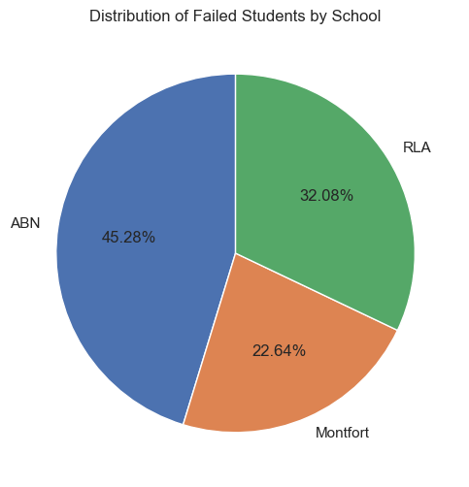
Creating Bar Plots

school_comparison = df.groupby('School_Name').agg(
avg_marks=('Overall_Marks', 'mean'),
passing_students=('Overall_Marks', lambda x: (x >= passing_marks).sum()),
total_students=('Student_ID', 'count'),
avg_family_income=('Monthly_Family_Income', 'mean')
).reset_index()
# Average Marks Comparison
plt.figure(figsize=(10, 6))
plt.bar(school_comparison['School_Name'], school_comparison['avg_marks'], color=['blue', 'orange','green'])
plt.title('Average Marks Comparison Between Schools')
plt.xlabel('School Name')
plt.ylabel('Average Marks')
plt.show()
# Passing Students Comparison
plt.figure(figsize=(10, 6))
plt.bar(school_comparison['School_Name'], school_comparison['passing_students'], color=['green', 'red','blue'])
plt.title('Passing Students Comparison Between Schools')
plt.xlabel('School Name')
plt.ylabel('Number of Passing Students')
plt.show()
# Average Family Income Comparison
plt.figure(figsize=(10, 6))
plt.bar(school_comparison['School_Name'], school_comparison['avg_family_income'], color=['purple', 'cyan','red'])
plt.title('Average Family Income Comparison Between Schools')
plt.xlabel('School Name')
plt.ylabel('Average Family Income')
plt.show()

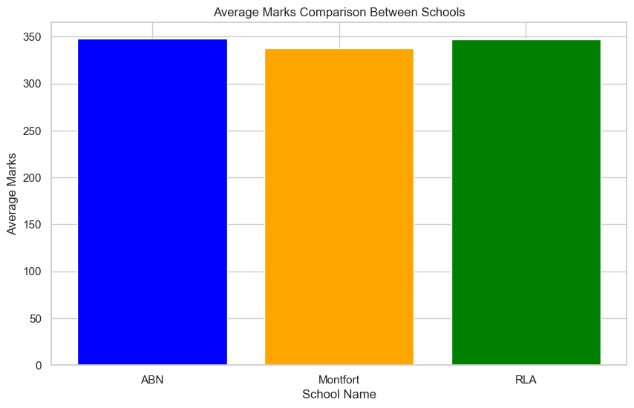
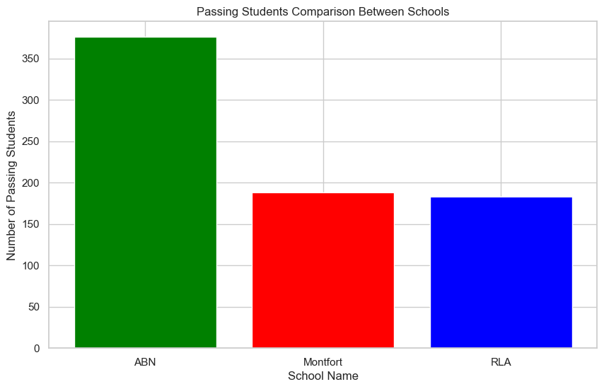
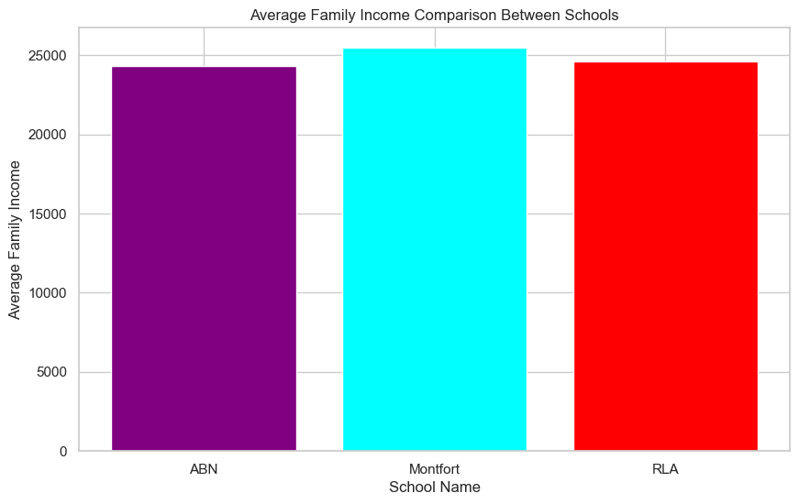
Income and Fees

school_comparison = df.groupby('School_Name').agg(
avg_marks=('Overall_Marks', 'mean'),
avg_family_income=('Monthly_Family_Income', 'mean'),
avg_fees=('Monthly_Fees', 'mean'),
total_students=('Student_ID', 'count')
).reset_index()
# percentage of income spent on fees
school_comparison['income_to_fee_ratio'] = school_comparison['avg_fees'] / school_comparison['avg_family_income'] * 100
# Monthly Fees Comparison
plt.figure(figsize=(10, 6))
plt.bar(school_comparison['School_Name'], school_comparison['avg_fees'], color=['blue', 'orange'])
plt.title('Monthly Fees Comparison Between Schools')
plt.xlabel('School Name')
plt.ylabel('Average Monthly Fees')
plt.show()
# Percentage of income spent on fees
plt.figure(figsize=(10, 6))
plt.bar(school_comparison['School_Name'], school_comparison['income_to_fee_ratio'], color=['green', 'red'])
plt.title('Affordability Comparison (Income to Fee Ratio)')
plt.xlabel('School Name')
plt.ylabel('Percentage of Income Spent on Fees')
plt.show()
#School comparison
print(school_comparison[['School_Name', 'avg_fees', 'avg_family_income', 'income_to_fee_ratio']])

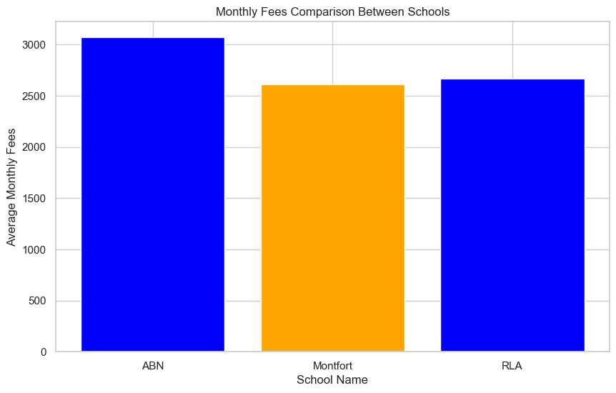
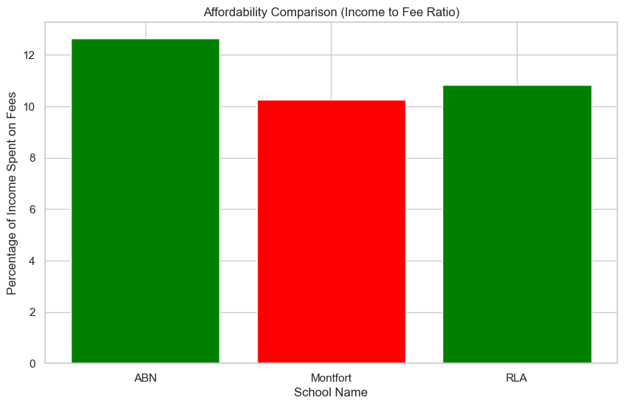

Finding outliers using IQR Methods

def find_outliers(df, column_name):
Q1 = df[column_name].quantile(0.25)
Q3 = df[column_name].quantile(0.75)
IQR = Q3 - Q1
lower_bound = Q1 - 1.5 * IQR
upper_bound = Q3 + 1.5 * IQR
return df[(df[column_name] < lower_bound) | (df[column_name]>upper_bound)]
outliers_marks = find_outliers(df, 'Overall_Marks')
outliers_income = find_outliers(df, 'Monthly_Family_Income')
outliers_age = find_outliers(df, 'Age')
print("Outliers in Overall Marks:\n", outliers_marks)
print("\nOutliers in Family Income:\n", outliers_income)
print("\nOutliers in Age:\n", outliers_age)

Outliers in Overall Marks:
Student_ID Class School_ID Overall_Marks Native Age \
266 267 6 1 57 Indian 11
307 308 7 1 55 Foreigner 15

Monthly_Family_Income School_Name Monthly_Fees Can_Afford_Fees
266 32839 ABN 3279 True
307 31366 ABN 1090 True

Outliers in Family Income:
Empty DataFrame
Columns: [Student_ID, Class, School_ID, Overall_Marks, Native, Age, Monthly_Family_Income, School_Name, Monthly_Fees, Can_Afford_Fees]
Index: []

Outliers in Age:
Empty DataFrame
Columns: [Student_ID, Class, School_ID, Overall_Marks, Native, Age, Monthly_Family_Income, School_Name, Monthly_Fees, Can_Afford_Fees]
Index: []

Giving Grades based on marks

def assign_grade(marks):
percentage = (marks / 500) * 100
if marks >= 450:
return 'A'
elif marks >= 400:
return 'B'
elif marks >= 350:
return 'C'
elif marks >= 300:
return 'D'
elif marks >= 200:
return 'F (Pass)'
else:
return 'F (Fail)'
df['Grade'] = df['Overall_Marks'].apply(assign_grade)
print(df[['Student_ID', 'Overall_Marks', 'Grade']])
Plotting graph of students based on grades
grade_counts = df['Grade'].value_counts()
plt.figure(figsize=(8, 6))
grade_counts.plot(kind='bar', color='lightblue', edgecolor='black')
plt.title('Distribution of Grades')
plt.xlabel('Grade')
plt.ylabel('Number of Students')
plt.xticks(rotation=0)
plt.show()

Student_ID Overall_Marks Grade
0 1 352 C
1 2 412 B
2 3 333 D
3 4 416 B
4 5 262 F (Pass)
.. ... ... ...
795 796 499 A
796 797 485 A
797 798 344 D
798 799 480 A
799 800 500 A

[800 rows x 3 columns]
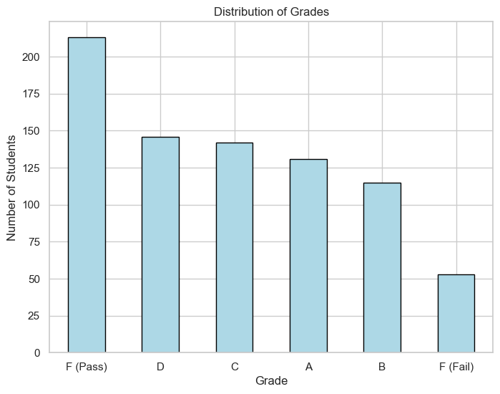
If Schools are planning a school trip what could be the cost per student and if the students can afford it or not and showing the list of students who cannot afford

transportation_cost = 200000
accommodation_cost = 1000000
food_cost = 50000
activities_cost = 300000
miscellaneous_cost = 200000
total_trip_cost = transportation_cost + accommodation_cost + food_cost + activities_cost + miscellaneous_cost
total_students = len(df)
cost_per_student = total_trip_cost / total_students
df['Can_Afford'] = df['Monthly_Family_Income'] >= cost_per_student * 2
students_can_afford = df['Can_Afford'].sum()
students_cannot_afford = total_students - students_can_afford
print(f"Total trip cost: {total_trip_cost}")
print(f"Cost per student: {cost_per_student}")
print(f"Number of students who can afford the trip: {students_can_afford}")
print(f"Number of students who cannot afford the trip: {students_cannot_afford}")
print("\nStudents who can afford the trip:")
print(df[df['Can_Afford'] == True][['Student_ID', 'Monthly_Family_Income']])
print("\nStudents who cannot afford the trip:")
print(df[df['Can_Afford'] == False][['Student_ID', 'Monthly_Family_Income']])
Total trip cost: 1750000
Cost per student: 2187.5
Number of students who can afford the trip: 771
Number of students who cannot afford the trip: 29

Students who cannot afford the trip:
Student_ID Monthly_Family_Income
41 42 2826
47 48 3467
71 72 1000
76 77 1661
97 98 4345
122 123 3896
140 141 1000
162 163 1000
196 197 1000
216 217 2773
263 264 1194
274 275 1000
290 291 2612
292 293 3689
404 405 1000
406 407 1000
477 478 3755
509 510 1000
531 532 2862
580 581 1000
606 607 1000
609 610 1000
616 617 2891
658 659 3987
670 671 4275
687 688 1000
732 733 1000
759 760 1000
799 800 2186

Hypothesis Testing

Using Independent Two-sample t-test (Comparing Schools)

Question: Is there a significant difference in the overall marks of students from Montfort and RLA schools?

from scipy import stats
montfort_marks = df[df['School_Name'] == 'Montfort']['Overall_Marks']
rla_marks = df[df['School_Name'] == 'RLA']['Overall_Marks']
t_stat, p_value = stats.ttest_ind(montfort_marks, rla_marks)
null_hypothesis = "The mean overall marks of students from Montfort are equal to the mean overall marks of students from RLA."
alternative_hypothesis = "The mean overall marks of students from Montfort are not equal to the mean overall marks of students from RLA."
if p_value < 0.05:
conclusion = "Reject the null hypothesis: There is a significant difference in the overall marks between Montfort and RLA."
else:
conclusion = "Fail to reject the null hypothesis: There is no significant difference in the overall marks between Montfort and RLA."
print(f"Null Hypothesis: {null_hypothesis}")
print(f"Alternative Hypothesis: {alternative_hypothesis}")
print(f"T-statistic: {t_stat}, P-value: {p_value}")
print(f"Conclusion: {conclusion}")
Null Hypothesis: The mean overall marks of students from Montfort are equal to the mean overall marks of students from RLA.

Alternative Hypothesis: The mean overall marks of students from Montfort are not equal to the mean overall marks of students from RLA.

T-statistic: -0.917416605626176, P-value: 0.3594799617430392

Conclusion: Fail to reject the null hypothesis: There is no significant difference in the overall marks between Montfort and RLA.

Using One-way ANOVA (Comparing Marks Across Classes)
Question: Is there a significant difference in the overall marks of students across different classes (Class 9, 10, 11, 12)?
class_marks = [df[df['Class'] == class_]['Overall_Marks'] for class_ in df['Class'].unique()]
f_stat, p_value = stats.f_oneway(*class_marks)
null_hypothesis = "The mean overall marks of students in all classes are equal."
alternative_hypothesis = "At least one class has a mean overall mark that differs from the others."
if p_value < 0.05:
conclusion = "Reject the null hypothesis: There is a significant difference in the overall marks across the classes."
else:
conclusion = "Fail to reject the null hypothesis: There is no significant difference in the overall marks across the classes."
print(f"F-statistic: {f_stat}, P-value: {p_value}")
print(f"Null Hypothesis: {null_hypothesis}")
print(f"Alternative Hypothesis: {alternative_hypothesis}")
print(f"Conclusion: {conclusion}")

Null Hypothesis: The mean overall marks of students in all classes are equal.

Alternative Hypothesis: At least one class has a mean overall mark that differs from the others.

F-statistic: 1.7122144714445997, P-value: 0.06633296267046353

Conclusion: Fail to reject the null hypothesis: There is no significant difference in the overall marks across the classes.

Using Pearson Correlation Test (Family Income and Marks)

Question: Is there a correlation between family income and overall marks of students?

corr, p_value = stats.pearsonr(df['Monthly_Family_Income'], df['Overall_Marks'])
null_hypothesis = "There is no correlation between family income and overall marks."
alternative_hypothesis = "There is a correlation between family income and overall marks."
if p_value < 0.05:
conclusion = "Reject the null hypothesis: There is a significant correlation between family income and overall marks."
else:
conclusion = "Fail to reject the null hypothesis: There is no significant correlation between family income and overall marks."
print(f"Null Hypothesis: {null_hypothesis}")
print(f"Alternative Hypothesis: {alternative_hypothesis}")
print(f"Pearson correlation: {corr}, P-value: {p_value}")
print(f"Conclusion: {conclusion}")

Null Hypothesis: There is no correlation between family income and overall marks.

Alternative Hypothesis: There is a correlation between family income and overall marks.

Pearson correlation: -0.039247956980613015, P-value: 0.26752021818790545

Conclusion: Fail to reject the null hypothesis: There is no significant correlation between family income and overall marks.

Using Chi-Square Test of Independence (Class and Affordability)

Question: Is there a relationship between the class of students and their ability to afford the trip (based on family income)?

contingency_table = pd.crosstab(df['Class'], df['Can_Afford'])
chi2_stat, p_value, dof, expected = stats.chi2_contingency(contingency_table)
null_hypothesis = "There is no relationship between class and the ability to afford the trip."
alternative_hypothesis = "There is a relationship between class and the ability to afford the trip."
if p_value < 0.05:
conclusion = "Reject the null hypothesis: There is a significant relationship between class and the ability to afford the trip."
else:
conclusion = "Fail to reject the null hypothesis: There is no significant relationship between class and the ability to afford the trip."
print(f"Null Hypothesis: {null_hypothesis}")
print(f"Alternative Hypothesis: {alternative_hypothesis}")
print(f"Chi2-statistic: {chi2_stat}, P-value: {p_value}")
print(f"Conclusion: {conclusion}")

Null Hypothesis: There is no relationship between class and the ability to afford the trip.

Alternative Hypothesis: There is a relationship between class and the ability to afford the trip.

Chi2-statistic: 8.551366340176216, P-value: 0.6632262629670261

Conclusion: Fail to reject the null hypothesis: There is no significant relationship between class and the ability to afford the trip.

Using T-test for Independent Samples (Comparing Age Groups)
Question: Is there a significant difference in the overall marks of students aged 10 or less and those aged greater than 10?
group_1 = df[df['Age'] <= 10]['Overall_Marks']
group_2 = df[df['Age'] > 10]['Overall_Marks']
t_stat, p_value = stats.ttest_ind(group_1, group_2)
null_hypothesis = "The mean overall marks of students aged 10 or less are equal to the mean overall marks of students aged greater than 10."
alternative_hypothesis = "The mean overall marks of students aged 10 or less are not equal to the mean overall marks of students aged greater than 10."
if p_value < 0.05:
conclusion = "Reject the null hypothesis: There is a significant difference in the overall marks between the two age groups."
else:
conclusion = "Fail to reject the null hypothesis: There is no significant difference in the overall marks between the two age groups."
print(f"T-statistic: {t_stat}, P-value: {p_value}")
print(f"Null Hypothesis: {null_hypothesis}")
print(f"Alternative Hypothesis: {alternative_hypothesis}")
print(f"Conclusion: {conclusion}")

Null Hypothesis: The mean overall marks of students aged 10 or less are equal to the mean overall marks of students aged greater than 10.
Alternative Hypothesis: The mean overall marks of students aged 10 or less are not equal to the mean overall marks of students aged greater than 10.
T-statistic: 1.0068556175118746, P-value: 0.3143093597459641
Conclusion: Fail to reject the null hypothesis: There is no significant difference in the overall marks between the two age groups.

